[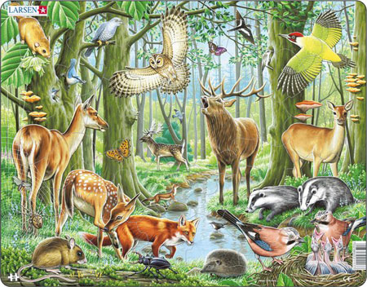](http://www.puzzle-offensive.de/Puzzle/fh17-Tiere-im-Wald-2006784.html) [](http://www.puzzle-offensive.de/Puzzle/fh17-Tiere-im-Wald-2006784.html)

[](http://www.puzzle-offensive.de/Puzzle/fh17-Tiere-im-Wald-2006784.html) [](http://www.puzzle-offensive.de/Puzzle/fh17-Tiere-im-Wald-2006784.html)

[](http://www.puzzle-offensive.de/Puzzle/fh17-Tiere-im-Wald-2006784.html) [](http://www.puzzle-offensive.de/Puzzle/fh17-Tiere-im-Wald-2006784.html)

[](http://www.puzzle-offensive.de/Puzzle/fh17-Tiere-im-Wald-2006784.html) [](http://www.puzzle-offensive.de/Puzzle/fh17-Tiere-im-Wald-2006784.html)